# Weekly fruit and veg box

This app is lighter on the database, unless you want to go down the delivery-driver route. Instead this app can revolve around personable design and ease of navigation, presenting a very appealing solution.

# Database design

This app can revolve around this design:

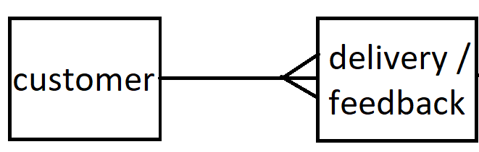

# Delivery / feedback

We make one of these per customer / per week on a standing order.

# Additional things to think about

Error handling

Testing

Documentation (User guide / walkthrough && readme)

# Alternatives

Any kind of online shop here can act as an alternative.